**User Manual for Finance Manager Application**

1. **Login Screen**

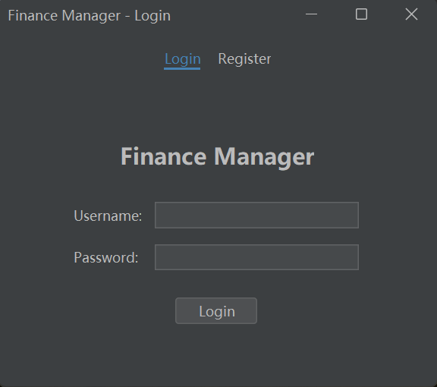

**1.login**

When launching the Finance Manager application, the user is first greeted with the Login Screen. The login screen provides two key input fields:

Username: Enter your registered username to access your account.

Password: Enter the corresponding password for your account.

Once the credentials are entered, click on the **Login button** to proceed.

1. **Register**

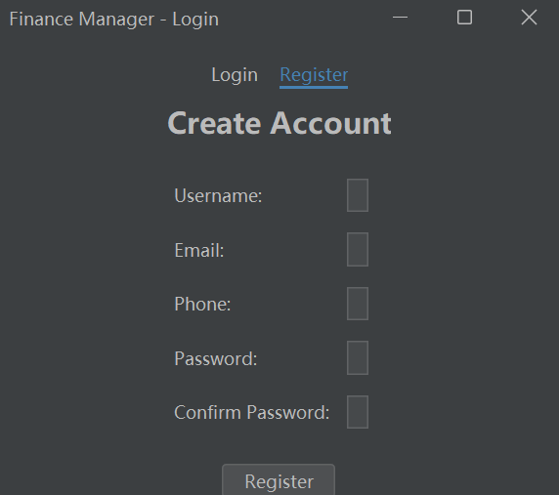

This feature is accessible by clicking on the Register button, which is located below the Login button. Here’s a breakdown of the registration process:

**Fields for User Input:**

When users click the Register option, they are presented with the following fields to complete their registration:

**Username:**

Users must enter a unique username that will be used to identify their account within the system.

**Email:**

The email field requires the user to input a valid email address. This email will be used for account-related notifications and communications.

**Phone:**

The phone number field allows the user to input their phone number.

**Password:**

Users must create a secure password to protect their account。

**Confirm Password:**

Users are asked to re-enter their password to confirm it. This ensures there are no typing mistakes and that both password fields match.

1. **Overview of the Dashboard**

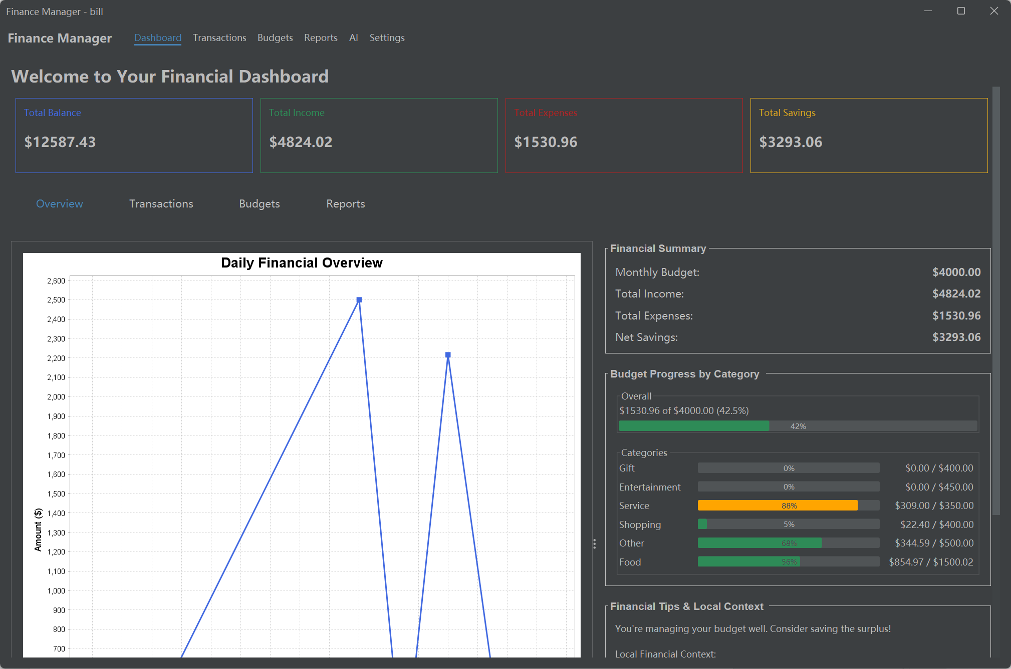

After logging in, the **Dashboard** screen will appear. This section is your main overview of financial information. It is divided into the following key sections:

In the **Overview** section of the Dashboard, you can easily navigate to other sections of the application by clicking on the various tabs and options available. This allows you to see simplified pages of **Transactions, Budgets, Reports, and AI**, providing seamless access to detailed financial data and management tools without leaving the dashboard.

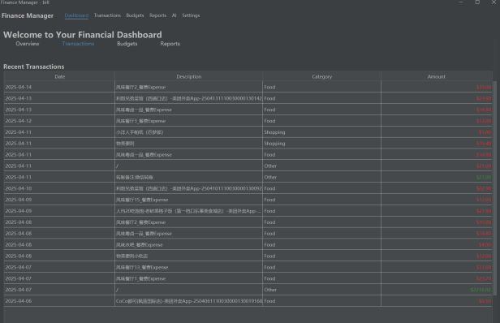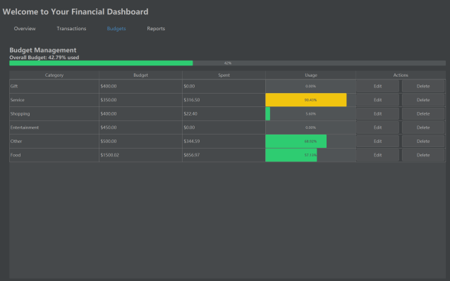

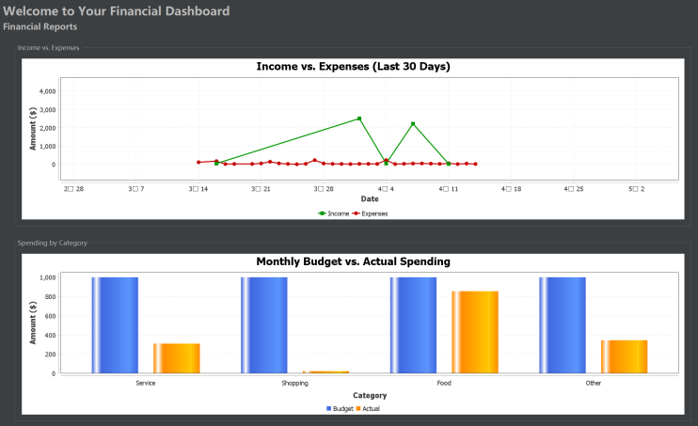

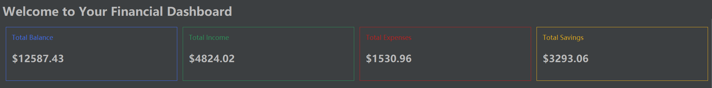

**Total Balance:**

Displays the total balance of your account(s), showing how much money you have.

**Total Income:**

Shows the total amount of income you have received for the selected time period.

**Total Expenses:**

This represents the total amount spent during the same period.

**Total Savings:**

The savings that have accumulated over time, calculated by subtracting your expenses from your income.

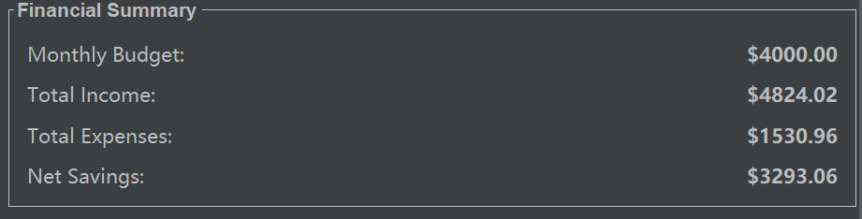

**Financial Summary:**

Monthly Budget: Your total budget for the month.

Net Savings: The difference between income and expenses, indicating your savings for the period.

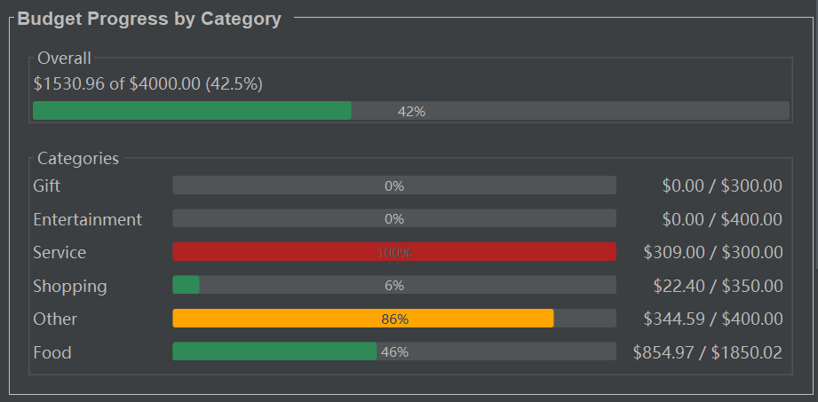

**Budget Progress by Category:**

Shows a breakdown of how your budget is being used across different categories like

Gift, Service, Shopping, Entertainment, Other, and Food. It visualizes the remaining budget and provides progress bars for each category.

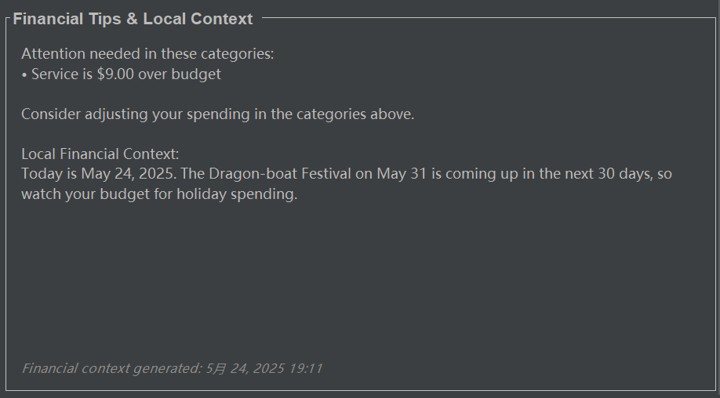

**The Financial Tips & Local Context section：**

It uses **AI** to provide personalized financial advice based on your spending habits and local events, helping you manage your budget effectively, **especially during key periods like holidays or festivals.**

1. **Transactions Page**

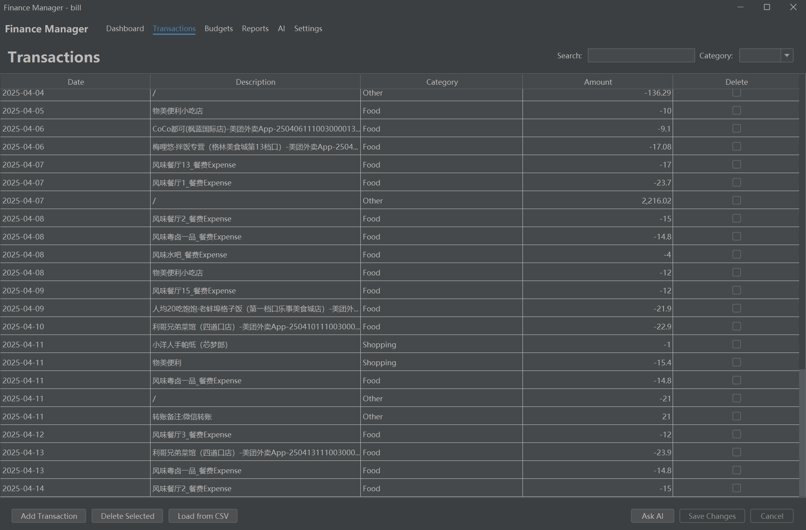

This screenshot shows the Transactions page of the Finance Manager application.

**Transactions Overview**

This page lists all financial transactions in a table format with the following columns:

**Date:** Displays the date of the transaction. For example, "2025-03-14".

**Description:** A brief description of the transaction. This may include the name of the store or service where the transaction occurred. For example, "物美便利店" (Wumei Convenience Store), "风味餐厅" (Flavor Restaurant).

**Category:** Categorizes each transaction into types such as:

Service、Shopping、Food、Other

This allows users to **easily categorize and track spending** in different areas.

Amount: The amount spent (shown as negative values) or earned (positive amounts). For example, "-100" means an expense of $100.

**Delete:** Checkboxes next to each transaction allow users to delete selected transactions if necessary.

**Search and Category Filter**

**Search Bar:** You can type keywords or transaction details into the Search bar to find specific transactions quickly.

**Category Filter:** This dropdown allows you to filter transactions by category (e.g., Service, Shopping, Food, Other). You can select a category to display only transactions that fall under that specific type.

**Action Buttons：**

Add Transaction: Clicking this button allows users to manually add new transactions to the system, entering details like date, description, category, and amount.

**Delete Selected:** This button deletes the transactions that have been checked using the checkboxes.

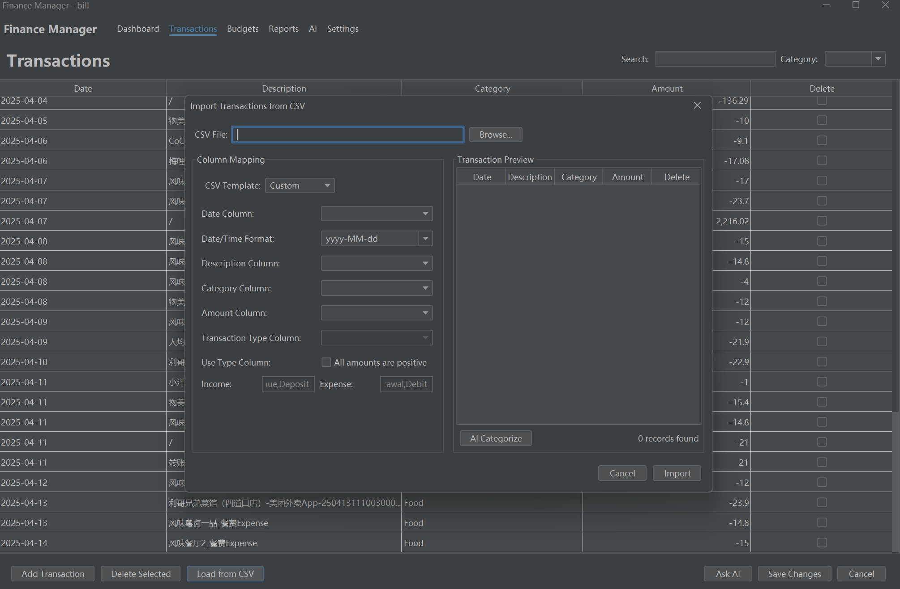

**Load from CSV:** If you have transactions stored in a CSV file, this option lets you import them into the system for easy management.

**Step 1:** Navigate to the Transactions Page

First, go to the Transactions tab on the Finance Manager dashboard. This is where you can view and manage all of your transactions.

**Step 2:** Open the "Load from CSV" Interface

In the Transactions page, you’ll find the "Load from CSV" button at the bottom of the screen.

Click on "Load from CSV", which will open the CSV Import Interface on the right-hand side of the screen.

**Step 3:** Select Your CSV File

Under the CSV File section, click on the Browse button to open a file dialog.

Navigate to the folder where your CSV file is located, select the file, and click Open.

The file path of the selected CSV will be displayed in the CSV File field.

**Step 4:** Map Columns to the CSV Template

The Column Mapping section is where you match the columns from your CSV file with the corresponding fields in the Finance Manager application. You will need to map the following columns:

**Date Column:** Choose the column in the CSV file that contains the transaction date.

**Date/Time Format:** Specify the format for the date in your CSV file (e.g., yyyy-MM-dd).

**Description Column:** Choose the column containing the transaction description.

**Category Column:** Select the column that contains the transaction category (e.g., Food, Shopping, etc.).

**Amount Column:** Choose the column with the transaction amount (positive for income, negative for expenses).

**Transaction Type Column:** If applicable, specify the column that identifies the type of transaction (e.g., Credit, Debit, Deposit, Expense).

**Use Type Column:** This allows you to specify if all amounts are positive or negative. Make sure to select the correct option based on the data in your CSV file.

**Step 5:** Preview and Adjust

After you have mapped the columns, you can see a Transaction Preview on the right side of the screen.

This preview allows you to verify that the data has been correctly imported from the CSV. Ensure that the Date, Description, Category, and Amount columns are correctly populated.

If you notice **any mistakes**, go back to the column mapping section and make adjustments.

**Step 6: Import the Data**

Once you’re satisfied with the preview, click on the Import button to load the transactions into the system.

The transactions from the CSV file will now be imported into your Finance Manager account and displayed in the Transactions table.

**Step 7: Post-Import Actions**

After the transactions have been imported, you can use other features like AI Categorize to help categorize transactions automatically or manually adjust any incorrect entries.

If necessary, you can also delete or modify transactions directly within the table.

**AI Assistance**

Ask AI: This feature **allows users to ask the AI for insights** related to their transactions. It can provide analysis, suggest improvements, or answer questions about specific spending patterns.

**Save Changes:** This button saves any changes you make to transactions or categories.

1. **Budget Management Page**

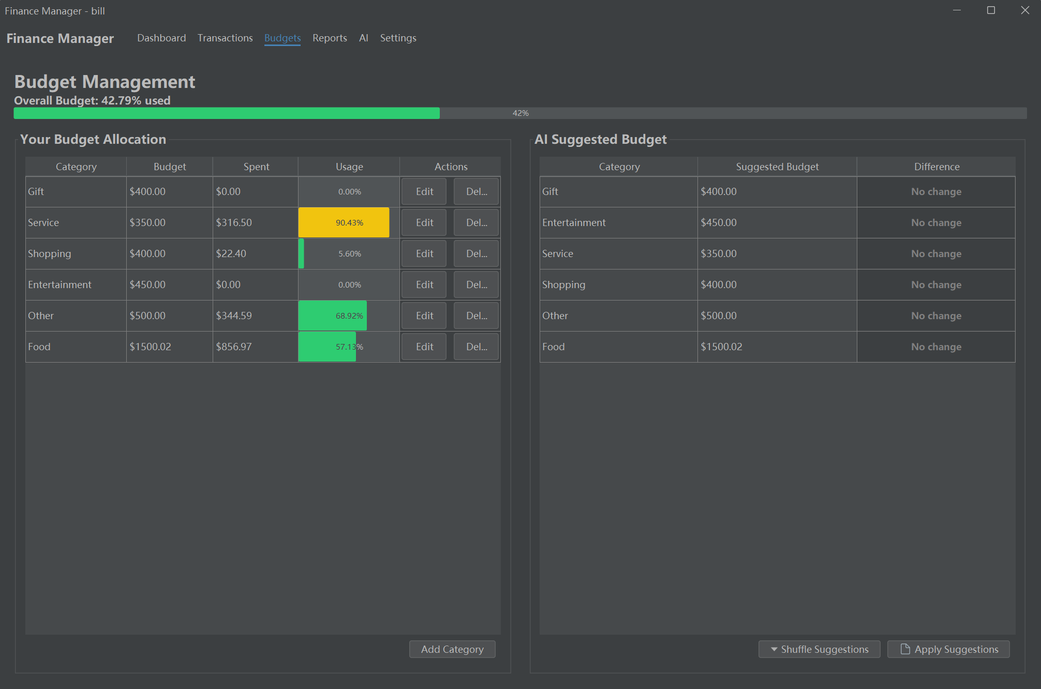

The Budget page helps you manage your finances by dividing them into categories like Food, Service, Shopping, etc.

This page shows:

**Your Budget Allocation:** Displays your spending allocation for each category, showing how much you’ve spent and what remains.

You can:

Edit: Adjust the budget amount for each category.

Delete: Remove any budget categories that are no longer needed.

Add Category: Add a new category for managing additional expenses.

**AI Suggested Budget:** Recommendations from the AI system based on your spending habits，and you can apply the recommendations.

1. **Financial Reports**

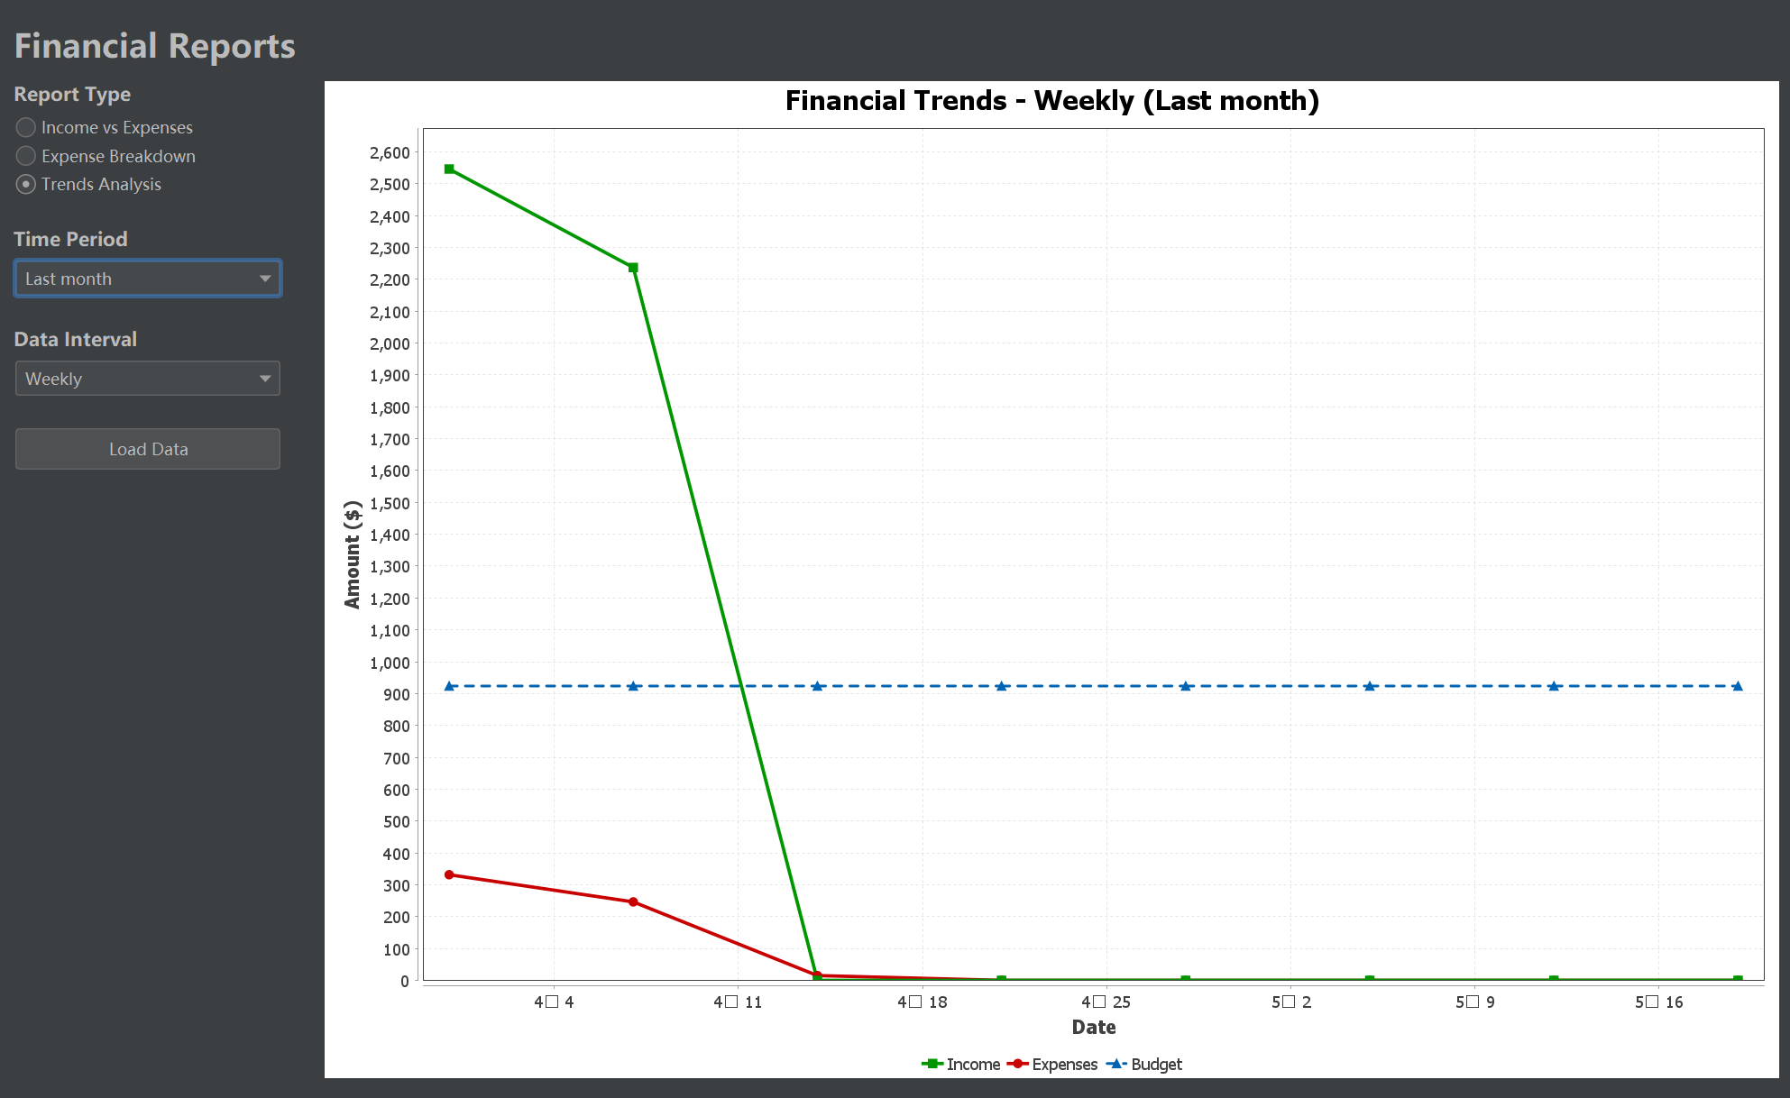

The Financial Reports page in the Finance Manager app allows users to visualize financial trends over time. The Trends Analysis report helps users track their income, expenses, and budget on a weekly or monthly basis. Here's how to use it:

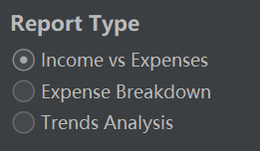

**Step 1: Select the Report Type**

At the top of the page, you'll find Report Type options. To visualize financial trends, select Trends Analysis.

Other options include Income vs. Expenses and Expense Breakdown, but for trends, we focus on Trends Analysis.

**Step 2: Set the Time Period**

Choose the Time Period for the report. You can select from the following options:

Last month: View the financial trends for the previous month.

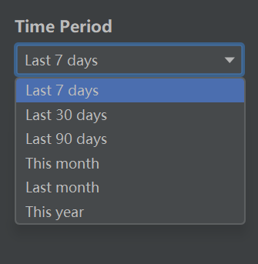

Last 7 days: Analyze trends for the past week.

This month: Review trends for the current month.

Custom: Select a custom range of dates.

After selecting the desired period, the chart will update to reflect the selected time frame.

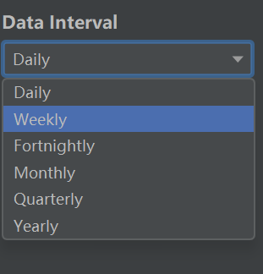

**Step 3: Choose the Data Interval**

Set the Data Interval to control how the data is grouped in the chart. Options include:

Weekly: The report will display income, expenses, and budget for each week.

Daily: View trends on a daily basis.

Quarterly:View trends on a quarter basis.

Monthly: See data aggregated on a monthly scale.

Fortnightly:View trends on a fortnight basis.

Yearly:View trends on yearly basis.

**Step 4: Load the Data**

Once you've selected the time period and data interval, click the Load Data button. This will update the chart with the financial data based on your selections.

The chart will now display three key lines:

**Income (green):** Represents the total income for each week (or chosen time interval).

**Expenses (red):** Represents the total expenses for each week (or chosen time interval).

**Budget (blue dashed line):** Displays the budget set for the corresponding time period.

**Step 5: Analyze the Trends**

The chart will allow you to visually compare your income, expenses, and budget:

Income Line (Green): Shows the amount of money coming in. Ideally, it should be above the expenses line.

Expenses Line (Red): Shows how much you've spent. Make sure this stays below the income line to maintain financial health.

Budget Line (Blue Dashed): Helps you compare actual spending to your planned budget. You should try to stay within the blue dashed line for financial control.

**Step 6: Adjust and Interpret the Data**

Use the trends shown in the chart to adjust your financial habits:

**Income spikes:** If your income is high during certain weeks, you might want to save the surplus or allocate it to savings.

**Expense spikes:** If expenses exceed your budget, look into the specific weeks to identify where the overspending occurred and adjust for future periods.

**Budget compliance:** Compare your expenses to your budget. If you're consistently overspending, consider adjusting your budget categories for better alignment with your actual spending.

1. **AI Assistant Page**

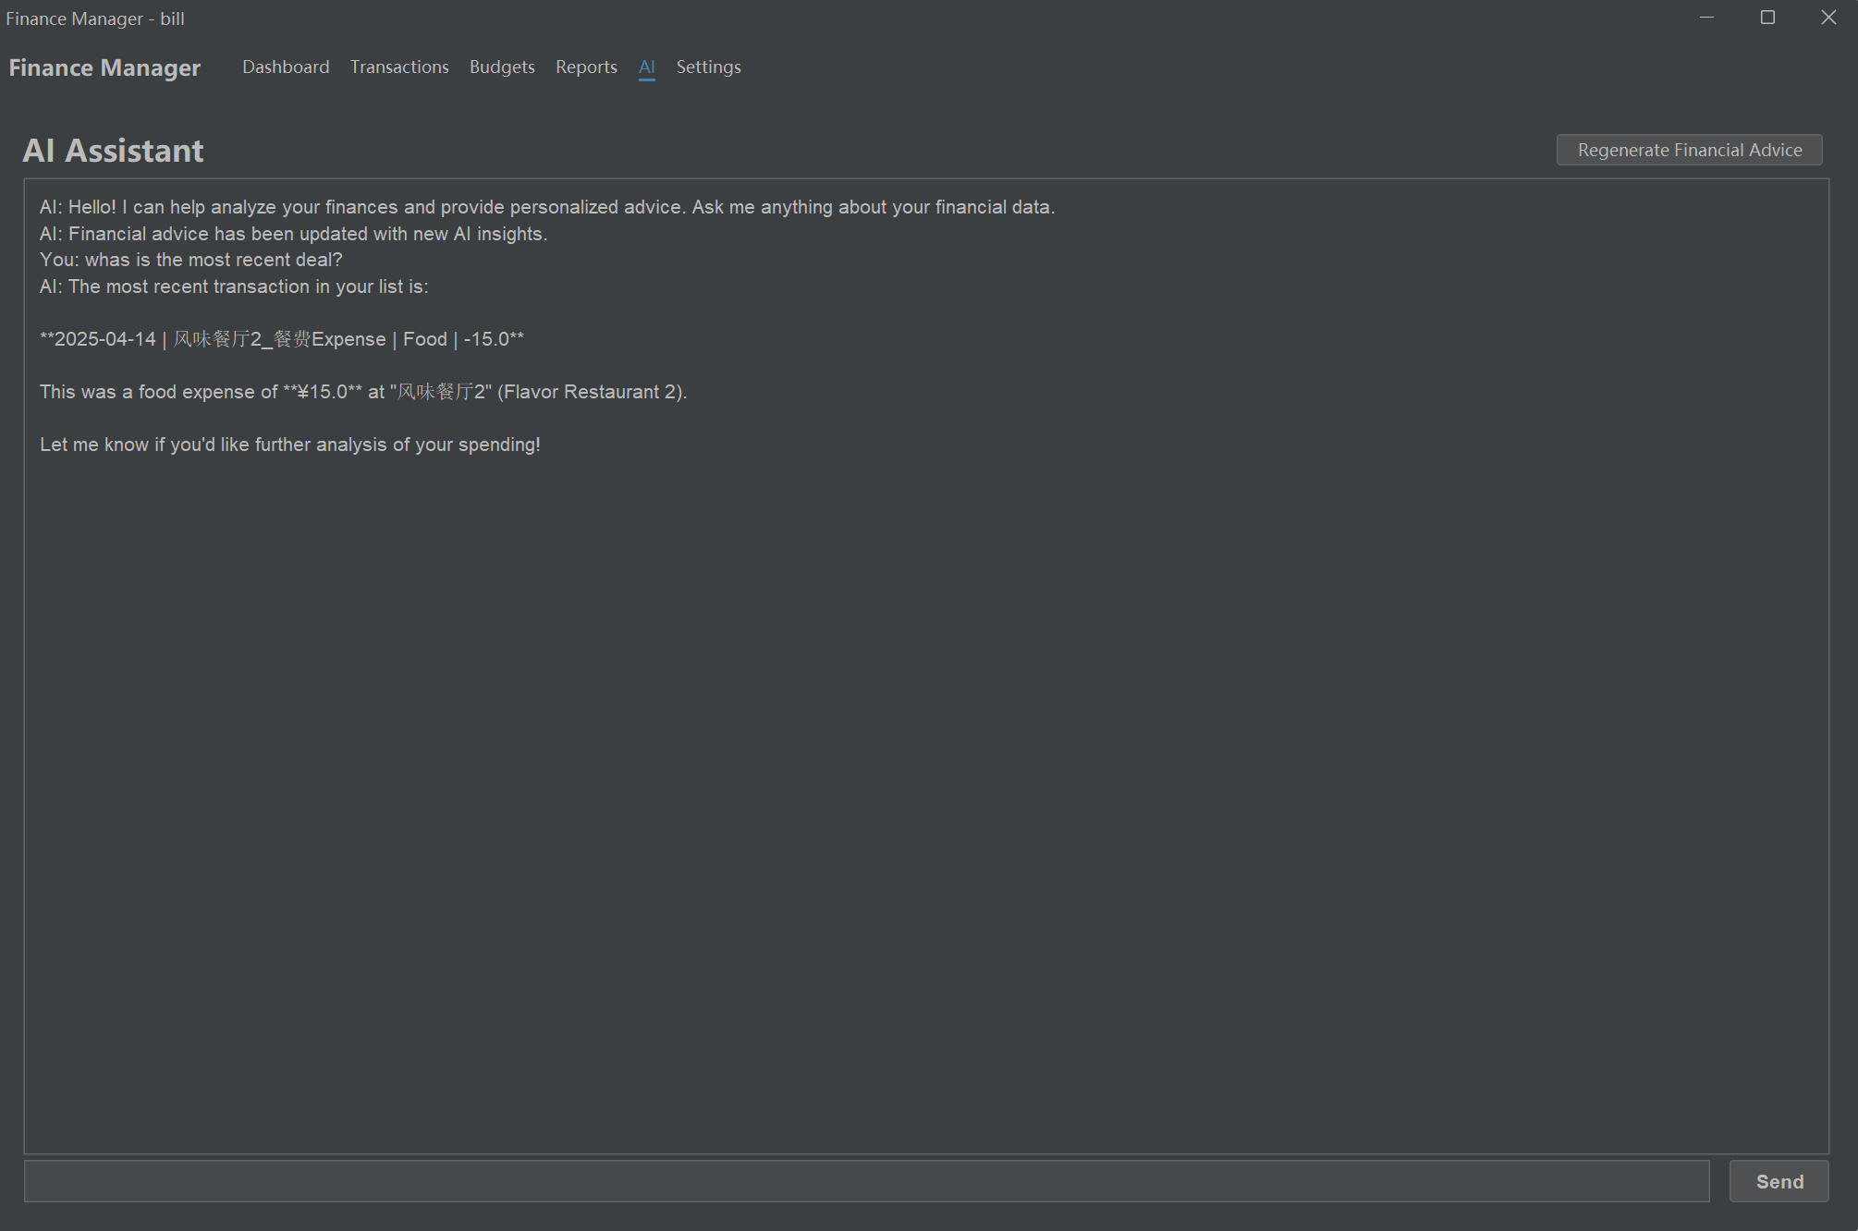

**AI Interaction Window:**

The main area of the screen is a chat-like interface where users can interact with the AI.

Users can type questions about their finances, such as asking for details about recent transactions or requesting advice about their spending habits.

**AI Response:**

The AI responds to user queries by providing personalized insights based on the user's data. In this case, the AI answers the question: “What is the most recent deal?”.

The AI provides a detailed response, identifying the most recent transaction, which is a food expense of $15.0 at Flavor Restaurant 2 on April 14, 2025.

**Regenerate Financial Advice Button:**

At the top-right corner, there's a Regenerate Financial Advice button. This allows users to refresh or get updated financial advice based on their current spending and transaction data.

Clicking this button will prompt the AI to provide new insights or tips, helping users stay on top of their financial situation.

**User Query:**

In the lower part of the chat interface, users can type their questions or requests. For example, the user asked: “What is the most recent deal?”

After typing, the user can press the Send button to submit their query to the AI, which will respond accordingly.

**Further Analysis Option:**

The AI's response also includes a suggestion: "Let me know if you'd like further analysis of your spending!"

This indicates that the AI can offer more detailed insights if the user wishes to explore specific financial trends, patterns, or areas of interest in more depth.

**How to Use the AI Assistant:**

**Ask Specific Questions:**

You can ask the AI for details about specific transactions or a summary of your expenses. For example:

“What was my last expense?”

“How much have I spent on food this month?”

**Request Financial Advice:**

If you need help understanding your spending patterns or want suggestions on saving money, you can ask the AI for general financial advice.

Example questions:

“How can I save more this month?”

“Should I adjust my budget based on my recent spending?”

**Get Updated Financial Insights:**

If you want the most up-to-date advice, simply click on the Regenerate Financial Advice button to receive new insights.

1. **Settings**

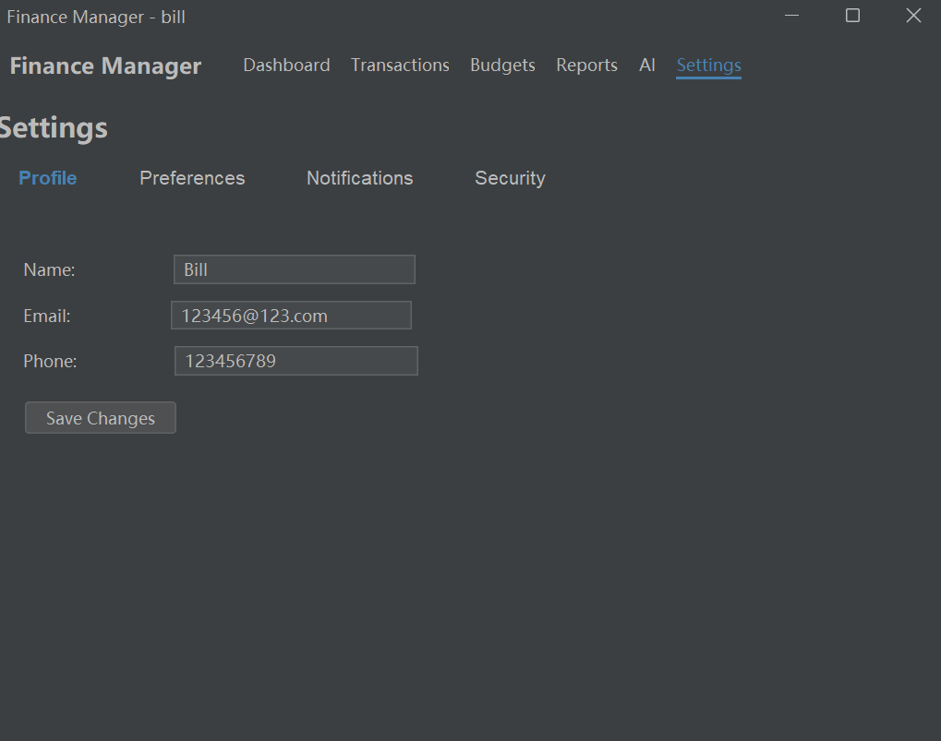The Settings page allows users to manage their profile, customize preferences, adjust notification settings, and configure security options. It is divided into several sections as shown in the top navigation bar: Profile, Preferences, Notifications, and Security.

**1.ProfileTab**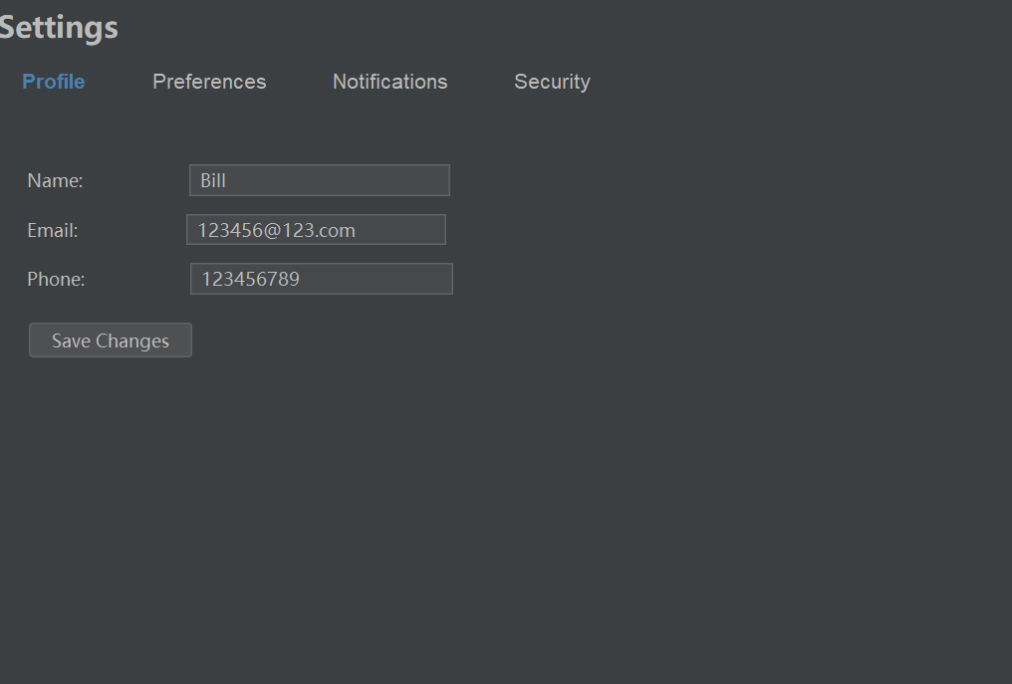

This section allows users to update their personal information. The fields shown are:

Name: The user can edit their name in this field.

Email: Allows users to update their email address.

Phone: Users can change their phone number here.

After making any changes, users can click the Save Changes button to save the updated information.

This information is essential for account identification and communication.

1. **Preferences Tab**

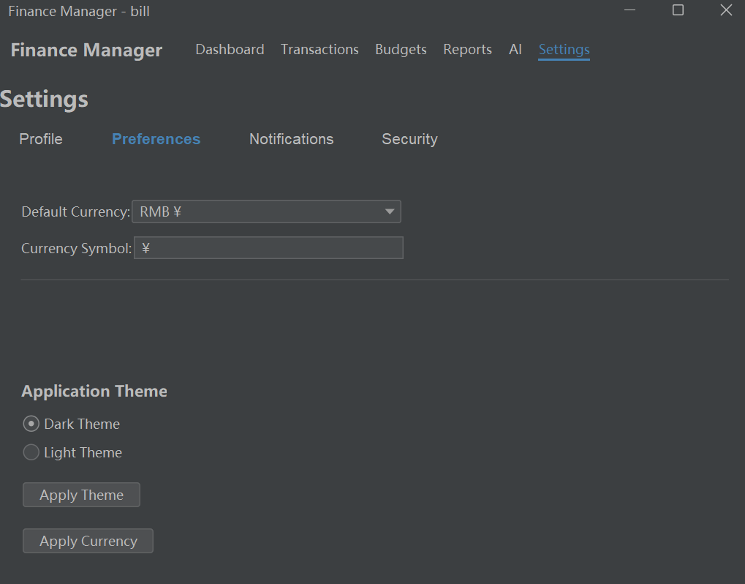

The Preferences tab allows users to personalize key settings in the Finance Manager application. It includes options for configuring currency settings and theme preferences, making the app more customized to each user's needs.

1. **Notifications Tab**

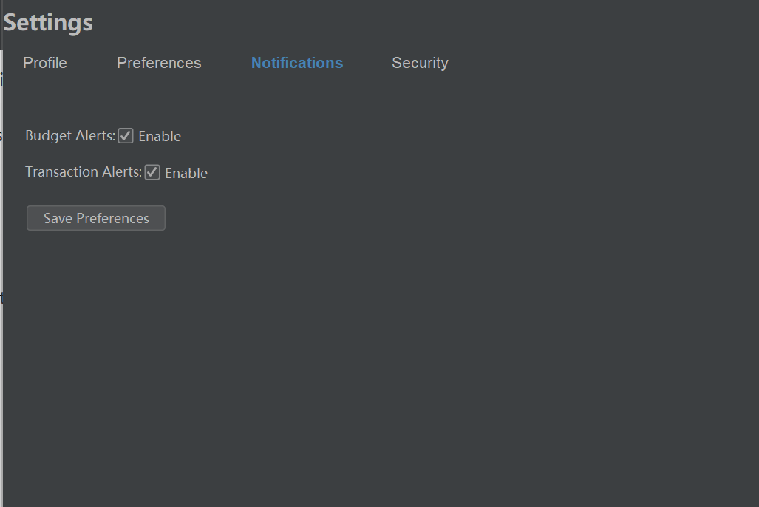

The Notifications tab within the Settings page allows users to customize how and when they receive notifications about their finances. It provides a way to ensure users stay informed about important financial events, such as approaching budget limits or recent transactions.

1. **Security Tab**

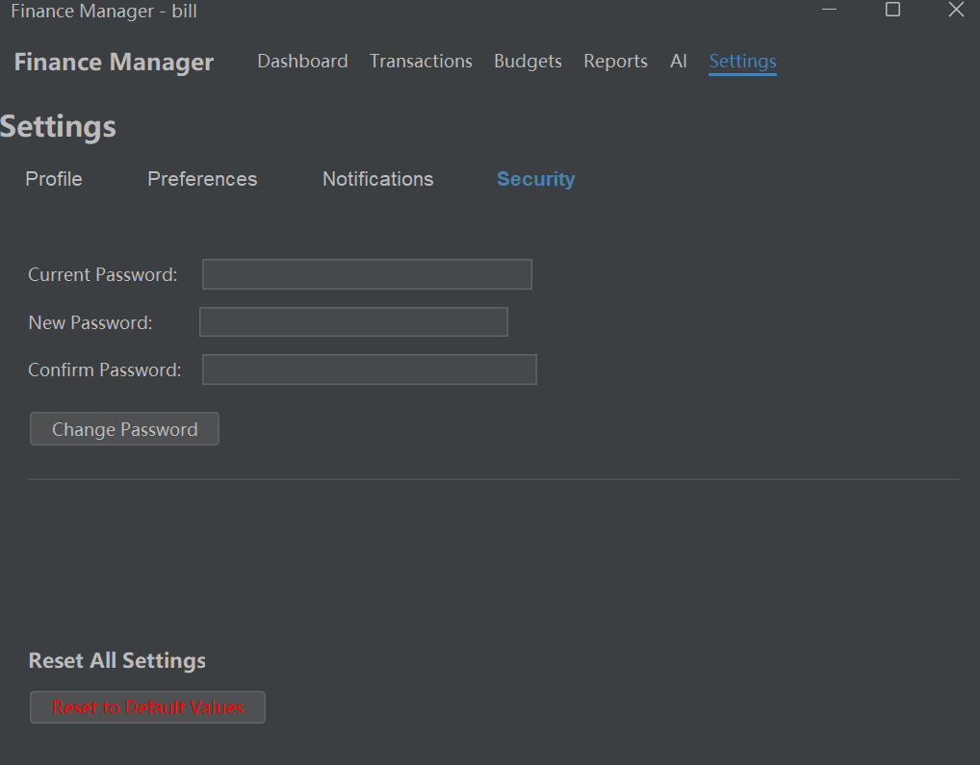

The Security tab within the Settings page allows users to manage important security features for their Finance Manager account. This section is critical for maintaining account safety, including changing the password and resetting application settings.